Lab 1
SQL Exercises

Notes:
- This lab consists of 2 parts (Part A: Managing Tables, and Part B: Querying Exercises). You are required to attempt all parts. You should spend on average 4 minutes on each question.
- To answer the questions in this lab, you can solely refer to the lecture notes posted in Moodle (Lecture 1c – SQL-Revision.ppt).
- All the questions need to be completed using SQL Query. You could cut and paste the SQL codes, if they are given. However, when you cut and paste the codes from Microsoft Word, be careful with the quote ('), as sometimes it may not be compatible with the text format in SQL.
- If you have not finished all the questions, you should complete them before the start of week-2 lab. Don’t get behind!!

PART A. Managing Tables

- After a successful login to your Oracle account using SQL Developer, type in the following SQL statement in the SQL Developer window:

SELECT * FROM TAB;

Write down your observation(s).

- Type in the following SQL statement

CREATE TABLE LECTURER
(StaffNO NUMBER(6) NOT NULL,
Title VARCHAR2(3),
FName VARCHAR2(30),
LName VARCHAR2(30),
StreetAddress VARCHAR2(70),
Suburb VARCHAR2(40),
City VARCHAR2(40),
PostCode VARCHAR2(4),
Country VARCHAR2(30),
LecturerLevel CHAR(2),
BankNO CHAR(20),
BankName VARCHAR2(40),
Salary NUMBER(8,2),
WorkLoad NUMBER(2,1) NOT NULL,
ResearchArea VARCHAR2(40),
PRIMARY KEY(StaffNo));

- Type in the following SQL statement:

SELECT * FROM TAB;

Write down your observation(s).

- Type in the following SQL statements

a)
INSERT INTO LECTURER (StaffNO, Title, FName, LName, StreetAddress, Suburb,City, PostCode, Country, LecturerLevel, BankNO, BankName, Salary, WorkLoad, ResearchArea)
VALUES (1000,'Dr','David','Taniar','3 Robinson Av', 'Kew', 'Melbourne', '3080', 'Australia', '5', '1000567237', 'CommBank', 89000.00, 2.0, 'O-R DB');
b)
INSERT INTO LECTURER (StaffNO, Title, FName, LName, StreetAddress, Suburb, City, PostCode, Country, LecturerLevel, BankNO, BankName, Salary, WorkLoad, ResearchArea)
VALUES (1000,'Ms','Julie','Main','6 Algorithm Av', 'Montmorency', 'Melbourne', '3089', 'Australia', '5', '1000123456', 'CommBank', 89000.00, 2.0, 'CBR');

What happens? Why?
Correct the mistake of the last SQL command by changing the staffNO to 2000.

c) Note: if you are entering values for all attributes, as in a) and b) above, you do not need to include the attribute names. Enter the following SQL statement:

INSERT INTO LECTURER VALUES (3000, 'Mr', 'Daniel', 'Wright', '22 Crystal Cres', 'Alphington', 'Melbourne', '3790', 'Australia', '5', '1000654321', 'CommBank', 89000.00, 2.0, 'DB');

d) However, if you are only entering partial information you MUST specify the attributes and ensure that all NOT NULL fields have a value. Enter the following SQL statement:

INSERT INTO LECTURER (StaffNO, Title, FName, LName, StreetAddress, Suburb, PostCode, Country, ResearchArea, Workload)
VALUES (4000, 'Mr', 'RaiHong', 'Lam', '12 Oracle Dr', 'Fitzroy', '3424', 'Australia', 'Data Mining', 1);

- Type in the following SQL statement:

SELECT * FROM LECTURER;

Write down your observation(s).

- a) Type in the following SQL statement. Note that in the following SQL statement,
the city is spelt with the case as follows: CiTTy

CREATE TABLE STUDENT
(StudentNO NUMBER(6) NOT NULL,
DOB DATE,
FName VARCHAR2(30),
LName VARCHAR2(30),
-- city spelt CiTTy
CiTTy VARCHAR2(40),
PostCode VARCHAR2(4),
Country VARCHAR2(30),
FeePaid NUMBER(8,2),
LastFeeDate DATE,
PRIMARY KEY(StudentNo));

b) Insert 5 student into the student table, with student number 30001, 30002, 30003, 30004 and 30005. Assign all attributes values. Note format for inserting date: ‘12-FEB-2002’.

Notes:
To Insert Records:

Format for inserting date and time into a table:
TO_DATE('12-MAR-2001 16:15', 'DD-MON-YYYY HH24:MI')

To Display/Retrieve Records:

Format for displaying date and time:
TO_CHAR(NameOfAttribute, 'DD-MON-YYYY HH24:MI')

For example:
SELECT TO_CHAR(SYSDATE, 'DD-MON-YYYY HH24:MI')
FROM DUAL;

- Type in the following SQL statement:

ALTER TABLE STUDENT ADD
(StreetAddress VARCHAR2(70),
Suburb VARCHAR2(40));

- Type in the following SQL statement:

DESCRIBE STUDENT;

Or

DESC STUDENT;

Write down your observation(s).

- Type in the following SQL statement:

ALTER TABLE STUDENT
DROP(CiTTy);

- Type in the following SQL statement:

ALTER TABLE STUDENT
ADD (City CHAR(40));

- Type in the following SQL statement:

ALTER TABLE STUDENT
MODIFY (City VARCHAR2(40));

Explain what the difference between CHAR and VARCHAR2.

- Type in the following SQL statement:

UPDATE STUDENT
SET StreetAddress = '12 New St'
WHERE StudentNo = 30001;

Display the contents of the Student table and write down your observation(s).

- Can you ADD a new field and DROP another field in one SQL Statement?

Explain your answer

- Type in the following SQL statement and explain what happens.

COMMIT;

PART B. Querying Exercises

- You should have 2 tables (Lecturer and Student tables) in your account where you have created in Part A (Managing Tables).

- Tables SUBJECT, LECTURE, TUTOR, LAB, STUDENT_ENROLMENT, and LAB_SIGNUP have been created in the dtaniar account. Several records have been inserted to this table. You can now import the tables into your account using the following SQL statement, for e.g.:

Create Table SUBJECT
As Select *
From dtaniar.SUBJECT;

You need to import all other tables (i.e. LECTURE, TUTOR, LAB, STUDENT_ENROLMENT, and LAB_SIGNUP). For your reference, the E/R diagram of these tables is shown below:

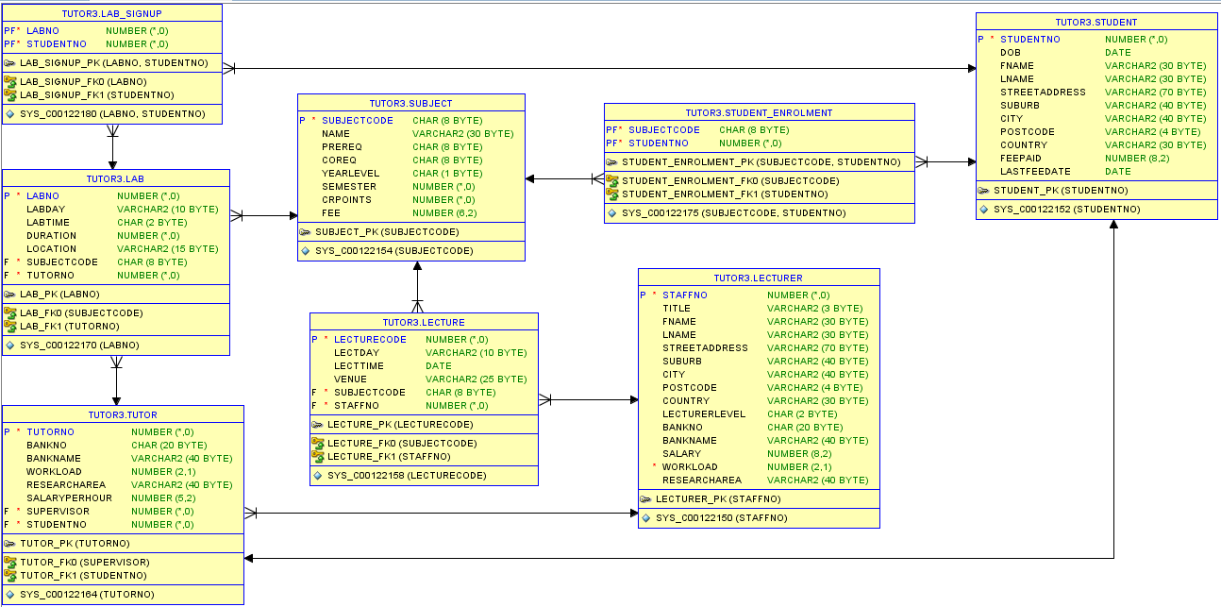

- Write an SQL statement to list all the lecturers and their lecture schedules

- Are there any lecturers who not teaching?

- List all the subjects offered in the first semester.

- List all the students by first-name, last-name, date-of-birth, and fee-paid details, who are born after 1990 and before 1995.

- List all the students enrolled in the database subject. (Note: database = CSE21DB, CSE31DB, CSE41FDB)

- List the students who are tutors.

- Select the lecturer(s) whose research area is ‘Network Management’.

- Calculate the average salary of a lecturer.

- Calculate the minimum and maximum salary of the lecturers.

- List the number of tutors by each subject and semester.

- List the total number of students in each lab, for each subject, with the tutor’s name.

- Calculate the cost of running all the database labs per week. (Hint: lab duration * tutors’ SALARYPERHOUR)

The End

